

**Starbucks**

**Strategic Management Report**

**Group members:**

**Aqsa Nadeem 1121646**

**Hedieh Ekhlasi 1132398**

**Saige Xie 1211246**

**Ying Deng 1205690**

**Ye Xiao 1211122**

**JingJing Zhang 1079310**

Table of Contents

Strategic Analysis: 2

Porter's Five Forces Analysis: 3

Competitor analysis: 3

SWOT analysis: 5

Stakeholder analysis: 6

Internationalization Analysis: 6

Strategic Issues: 8

External analysis or organization based view: 8

Internal analysis or resource based view: 9

Market Based View: 9

International level: 10

Future Strategic Options: 11

Strategic direction: 11

Business level: 12

Resource Based View: 12

Market Based View: 12

International level: 12

Strategy Evaluation and Selection: 14

Suitability: 16

Acceptability: 17

Feasibility: 19

Future Recommendation: 21

References: 23

# Strategic Analysis:

Starbucks has excelled in the past but its recent performance has been poor due to changes in the market environment and growing competition in the coffee industry. The historical net earnings of Starbucks are shown in the graph below.

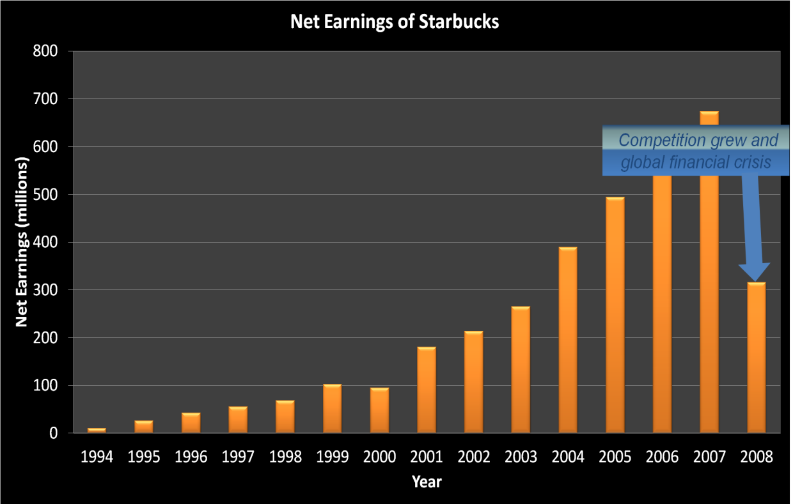

Figure 1: Net Earnings History

From the above graph it can be seen that the net earnings fell from 700 million in 2007 to nearly 300 million in 2008. Therefore Starbucks needs a strategic analysis to look for the causes and implement new changes which would help to regain its position back to the top in the existing market. This evaluation has been carried out by our consultation team.

Starbucks was established in Seattle, USA in 1971. Today, there are 17,009 stores in 50 countries. Starbucks product include coffee, handcraft beverage, coffee-making equipment, fresh food, and branded products. The number of employees is 176,000 in the world and 143,000 in US (Fiscal 2008 Annual Report, Starbucks Corporation). US accounts for approximately 70% of sales.

Starbucks are in 50 countries such as UK, China, Mexico, NZ, Russia, Brazil etc. Basic menu of beverage is 6 types which are Brewed coffee, Chocolate Beverages, Espresso Beverages, Frappuccino Blended Beverages, Kid’s Drinks and Teas, however, the rage of menu depends on the countries. That is why there is wide range of menu in the world. For example, tastes of Sakura in Japan.

During 2002-2006, the company's revenues, operating profit and net profit grew at a CAGR of 24%, 28.6% and 28.6% respectively. Moreover, the company's average return on equity and return on investment during 2002-2006 were 19%, and 18% respectively, significantly higher than the industry averages of 15.3% and 11.3%. Though it suffers decline during the year 2007 and 2008, it is still one of the most stable and fast growing companies in the year 2008.

## Porter's Five Forces Analysis:

**The threat of entry**: low.

Starbucks is a company that have years of experience in roasting specialized coffee. It would be extremely difficult for new competitors to offer the same quality of coffee at the same competitive price.

**The power of buyers**: high.

Starbucks does face a high buyer power challenge because of the nature of the industry. The customers demanding for coffee have no switching costs to change their brand choice. This implies that the cost leadership strategy in this industry will tend to suffer severe competition and surprisingly low profit.

**The power of suppliers**: low.

Starbucks buy their coffee beans directly from producing countries: Latin America (50%), Pacific Rim (35%) and East Africa (15%). The company’s fixed-price and price-to-be-fixed supply chain gives it a certain level of power against suppliers.

**The threat of substitutes**: high.

Starbucks is facing great substitute challenges of cheaper coffee provided by competitors, and ‘coffee-at-home’ maker machines. All the instant/homemade (caffeinated) drinks such as juice, cola, water, can be a substitute threat to Starbucks.

**Competitive rivalry**: high.

Starbucks is mainly facing rivalry from catering establishments such as McDonalds’, which are exploring the market of premium coffee; it also has other small stores or imitators as competitors (e.g. Caribou), but they contribute less to the intensity of the competition according to the data presented. Starbucks competes with a variety of smaller scale specialty coffee shops, mostly concentrated in different regions of the country. All of these specialty coffee chains are differentiated from Starbucks in one way or another. Starbucks faces severe competition in some of the global markets, mainly from the Italian coffee store Illy and other already-well-developed local/global companies (e.g. Costa Coffee).

## Competitor analysis:

The main competitive forces at work can be summarized as the following:

Catering establishments (McDonald’s or similar catering establishments), specialist coffee chains/imitators (Caribou or similar specialty coffee store), global markets’ local competitors (Illy or similar premium coffee provider), fine coffee makers for home-made coffee (Nestle or similar instant coffee and coffee machine supplier), minor competition include other kinds of drink product suppliers.

The Strategic Group Analysis mapping can be seen as follow:

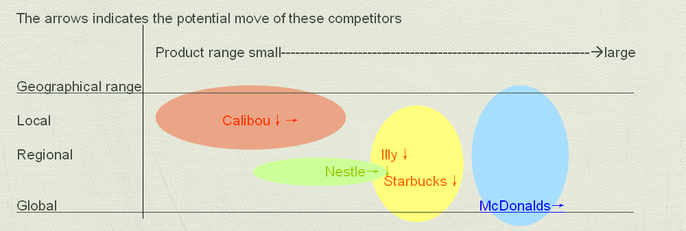

Figure 2: competitor analysis

Competition is steadily growing against Starbucks each year as the industry grows. Competitors look to gain an advantage by price cuts, launching a rival product, aggressive expansion of production to increase market share or inclusion of significant modifications to a product that other competitors must also undertake to keep up. At the end of 2008, Dunkin’ Donuts was close to Starbucks in number of retail stores with 8,835 stores worldwide, including 6,395 franchised restaurants in thirty-four US states and 2,240 international shops in thirty-one countries

Following the analysis above, we can conclude that the two significant competitors in this year will be McDonald’s and Caribou.

McDonald’s

The company will be installing coffee bars along with "baristas" who will serve cappuccinos, lattes, mochas and the Frappe, a knockoff of the Starbucks’ ice blended Frappuccino, throughout 2008 and into the beginning of 2009. The competitive threat posed by McDonald's can be summarized by referring to the February 2008 edition of the Consumer Reports magazine, which rated the McDonald's drip coffee as better tasting than Starbucks. (Adamy, McDonald's Takes on Starbucks, 2008)

Caribou coffee

Caribou Coffee is similar to Starbucks in their attempt to create a third-place. Where Starbucks strives to create an upscale European atmosphere, Caribou coffee tries to implement a more American feel to their coffee houses. They do this by modelling their coffee houses after rustic Alaskan lodges. (Quelch, 2006) Founded in 1992, Caribou coffee now operates roughly 500 stores, employs over 6000 people and grosses roughly $230 million in revenue a year. (Caribou Coffee, 2008)

## SWOT analysis:

Starbucks’ current internal position can be evaluated as this SWOT mapping:

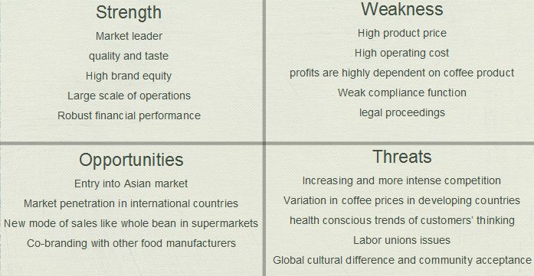

They are facing great opportunities both in the mature market of US and in the new market globally. Its robust financial performance in recent years provides it the financial backgrounds to explore new geometrical market opportunity, which we have seen remarkable growth rate of revenue of 24.0% this year (Starbucks Corporation Fiscal 2008 Annual Report). Starbucks’s good reputation of brand and product (Shultz, Pour Your Heart Into It: How Starbucks Built a Company One Cup at a Time, 1997, p. 114) gives it great power choosing co-branding or licensing partners. However, the current global economic environment and market trend of increasing competition as well as the growing consideration of healthier lifestyle cast potential threats to the corporation. Starbucks high profit dependency on raw material costs and increasing product recall in recent days show the corporation has its weaknesses.

## Stakeholder analysis:

It can be seen in the past few years that the employee/supplier/community relations can largely decide a local outlet’s sales and competition intensity.

As a large corporation Starbucks draws various groups of stakeholders’ attention. The major stakeholder mapping can be seen as follow.

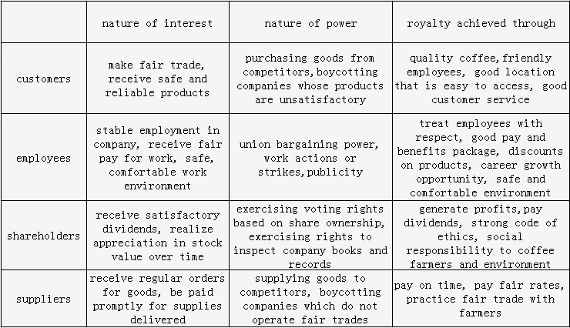

## Internationalization Analysis:

Starbucks expanded very rapidly in some markets after it first stepped out in 1996 from its home, USA into Japan. It focused on creating the “coffee experience” which is part of its strategic objectives. Starbucks implemented new differentiation strategies on the spot wherever the need arose for example in Italy the people prefers food with coffee and Starbucks had to fulfill this demand by increasing its expenditure on food to sustain itself in the market. Similarly in China people still prefer tea rather than coffee so Starbucks went under product innovation to make a mixed blend of tea and coffee especially for its customers in China.

To survive in international markets it is essential to catch up with the cultural trends and create local flavors to keep hold of the market share, keep customers attracted and hence generate income which is the sole purpose of expanding internationally. The other issue when tackling globalization is that of store ownership, political situations and face other legal enforcements depending on each country. Starbucks still has very few licensed stores in international market and to save costs it needs to start buying those stores rather than wasting so much money on rents.

All in all, Starbucks had performed well in international market but there are still some unexplored markets which need to be discovered to the benefit of the organization.

# Strategic Issues:

Following that analysis, issues of company can be concluded in weaknesses and threats in SWOT analysis, opportunities that need to consider being competitive in the worldwide market, and also barriers to prevent them from implementing current strategies successfully. Market based, resource based, organization based, and also corporate and international based views were evaluated to achieve this issues list:

1. Cannibalization of the brand value
2. Over-crowded in urban areas

Organization Based View

1. Scarcity of stores in suburban areas
2. Under-Sized of stores
3. Not enough drive-thru
4. Concentration of investments on the same type of products

Resource Based View

1. High Prices products
2. Lack of internal focus-leadership
3. Poor advertising
4. Achieve customer and supplier loyalty

Market Based View

1. Need of more wide-spread customers
2. Increased number of competitors
3. Cost cutting
4. Strong presence in US

Internationalization Level

1. Cultural and political issues in foreign countries

Strategic issues are the issues coming from analysis with the goal of going toward the company’s mission, vision and values. Considering this definition, all the issues above are strategic issues with different level of importance, different impact on competitive position of company and also different priorities.

## External analysis or organization based view:

As Howard Schultz, founder of Starbucks, announced on February 2007: “stores no longer have the soul of past and reflect a chain of stores vs. the warm feeling of a neighbourhood store” company aggressive expansion had the result of commoditization of brand value. In less than 2 decades, Starbucks number of stores went from less than 1000 to more than 14000 across the globe. This expansion decisions might were right at that time, however, after a while the problems shown up one after another.

Firstly, Starbucks lost its initial sought, bringing a relaxed environment instead of “grab and go” places such as MC Donald and Dunking Doughnut.

Secondly, the next problem need to be mentioned is some areas have more stores than it needed. Having two or more stores in less than a kilometre street ruined the value of Starbucks in their customer’s minds. On the other hand, some suburban areas facing lack of stores problem. Customers argued they could not find Starbucks in many areas.

Thirdly, this store openings strategy creates only superficial growth. As store managers require achieving brand loyalty and increasing the store revenue, the other store had opened nearby. This happening not just affects the brand value, but also influence on manager morale.

Moreover, Size of stores was an issue that some customers were not happy about. Stores did not have enough seats and tables especially on rush hours. Not enough parking spaces and not enough drive-thru stores can be included on this external analysis issues.

## Internal analysis or resource based view:

As we mentioned above, the current expansion strategy also has influence on resource based of organization.

Starbucks initial goal to be a luxury, high price-high quality brand has been lost by fast growing expansionism. First problem aroused when Starbucks introduced new stores in the form of Express. This type of stores was designed for another segment whom service means speed of delivering orders. However, this price seemed not suitable for Express customers, McDonald’s and Dunkin Donuts were offering their coffee with much lower price.

Second issue might be lack of internal focus, due to focusing more than needed on expansion, whether in US or in global level. Designing the stores and human resources selections are two major parts that been forgotten by top managers.

Although Starbucks had product innovations in their menu, but most of the products are coffees or coffee related. As people going to a healthier way, they are thinking about deleting caffeine from their diets. This problem had direct effect on Starbucks customer’s reduction.

## Market Based View:

Initial goal for every organization to stay alive, is to make higher profit and make the operation cost as low as possible. Starbucks high operation cost would not allow to make the profit high, even though with the high priced products. Besides some manager’s thinking, cost cutting is the issue that need to be considered perfectly.

Another issue in this area is limited source of good quality coffee beans. Supply chain management need to reconsider the current strategy to make better relationship and higher trust with farmers. Customer loyalty and supplier loyalty are the most effective factors for initial sought of this company, offering high quality-high price products.

## International level:

As we mentioned, Starbucks is earning more than 75% of its revenue from USA market. This strong presence in US market, even after economic crisis, has become a reason for dropping its growth rate. Although this economic crisis was global, USA has one of the most effective markets among all countries. In order to expand internationally, Starbucks needs to be adoptive to different cultures and different politics. Entering to Brazil market was one of the biggest issues that Starbucks faced during last decade.

After analysing issues and consolidate overlapping, some of them were deleted from the list. The following table is showing the issues in temporal order:

|  |  |  |  |
| --- | --- | --- | --- |
| Priority rank | issues | Impact on competitive positioning | functions |
| 1 | Cannibalization of brand value | 9 | OBV |
| 2 | Strong presence in US | 4 | internationalization |
| 3 | Cultural and political issues in foreign countries | 7 | internationalization |
| 4 | Cost cutting | 10 | MBV |
| 5 | Lack of internal focus | 8 | RBV |
| 6 | Achieve supplier loyalty | 1 | MBV |
| 7 | High price product | 2 | RBV |
| 8 | Lack of product innovation | 6 | RBV |
| 9 | Undersized stores | 3 | OBV |
| 10 | advertising | 5 | MBV |

# Future Strategic Options:

Strategic directions and strategic methods are two subheadings that explained below.

## Strategic direction:

By considering the existing issues, developing various strategic options is necessary. As Starbucks has its own strategic capability, expectations and purposes in the environment, we identify the possible development directions build on Starbucks strategy position. Although strategic development directions can be represented into Ansoff Matrix below:

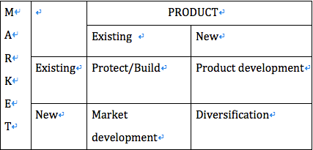

In practice, if Starbucks is to develop successfully in the future, a combination of development directions is usually pursued. Starbucks had a level of culture in its business that would be the envy of many small business owners, therefore it needs to protect and strength its positions in the current markets with current products. Since the market situation is likely to be changing, consolidation does not mean standing still. Indeed, it may require considerable reshaping and innovation to improve the value of Starbucks products or services (eg, through downsizing or withdrawal and maintenance of market share).

If Starbucks intends to gain more market shares, we suggest with market penetration and introduce the opportunities that Starbucks needs to seize. Starbucks moved rapidly since 2002, in these years, most small companies may face a failure in business. The opportunities to gain share through acquisition of failing companies may arise, at the same time, Starbucks needs to shut down stores with lower profits and can also introduce new brands by changing store titles or styles, it might be helpful to attract another groups of customers and this will not damage the image of Starbucks as it’s still in charge of core concepts. On the face of keeping the old customers, Starbucks may protect its reputation by increasing the quality and quantity of comfort utilities (sofas, children’s goods, designing for the disabled, high speed internet, etc.). As people seek a more convenient way to purchase coffee, drive-thru market is growing, Starbucks can be treated as a new entrant, it’s easier for Starbucks to gain share, in some instances, Starbucks should be able or willing to meet the new demand.

In existing market, changes in business environment may create the demand for new products and services. For Starbucks, extending the organizational scope is limited, even market penetration will probably create the need of product development, this implies greater degrees of innovation. Such development would include moving the drinks from sweet taste to low calorie, low sugar and energy drinks. On other hand, the launch of liqueur drinks is also attractive. By considering making coffee effectively, through more advanced coffee machine, costs and redundant employees would be reduced. However, product development can be costly and high risky.

Let’s move away from both existing products and markets, we recommends that Starbucks can invest in airline drinks market and food package manufacturing. It may also specialize in food research and development to diversify its products, such as coffee taste ice cream and chocolate bars.

## Business level:

Coffee price in Starbucks is higher than others in the same market. So how can Starbucks compete effectively to achieve the competitive advantage? Such options can be generated in TOWS matrix and summarized in SWOT analysis.

### Resource Based View:

In order to add value, Starbucks can take part in these activities such as find low cost raw materials, this can be achieved by supporting the farmers/suppliers then negotiate better prices for the same quality, standardize products and use high-efficient machines. At the same time, differentiate products, advertising and promote non-standardised items and serve customers in a high level. Then use three criteria (Architecture, Reputation, Innovative capability) to examine if the options would be to reduce costs or not.

### Market Based View:

Starbucks can be smart to lower the price in a temporary time or public holidays thus win a price war, it can also brand a second, low-price products. Because of the high quality coffee, it’s not necessary to argue with the high price Starbucks charges its customers. However it’s not enough for achieving cost and value advantages. Using differentiation can be another way to generate these advantages, in instance, Starbucks can emphasis on designing and product development, so it can charge higher price on distinctive products. And even use co-branding to increase the premium consumers are willing to pay.

### International level:

“Analysts have noted that Starbucks store’s base is maturing, leading to a slowdown in the growth of unit volume and firm profitability.”(The Washington Post, August 1, 1995) In this circumstance, Starbucks is entering most of the international market including Russia, Brazil, China and Western Europe (except a major country: Italy).

How to compete successfully in host countries?

Brazil:

It is the largest coffee-producing country, due to several issues such as growing violence, street crime and anti-American culture. Starbucks can (MBV) locate stores in fashionable shopping malls, offer Starbucks’s products on RIo-Grandense Air Lines and export Starbucks concept into music/movie. Though there is no joint venture partner, Starbucks may invest and establish 100% controlled unit. And (RBV) it’s quite important to keep close relationship with local suppliers, farmers and employees to procure high quality effectively.

China:

We are concerning about the nationalism and culture in this country. By thinking of Beijing’s Forbidden City case, in order to avoid ruining the atmosphere of historical sites, STARBUCKS can (RBV) change the modern decorations and keep its stores apart from these sites and (MBV) advertise tea and Chinese traditional dim-sum under the brand. And (OBV) should also make efforts to inspire and reward its partners (Healthcare, income protection).

How to enter Italy market?

Coffee experience in Italy is very different from Starbucks can offer, it’s more personal and intimate. There’s a battle between “slow food” and “fast food”. So the attempt for entering Italy is particular difficult therefore may not be able to find a suitable target for acquisition. Under this issue, adopting strategies like internal development and alliances is helpful.

Firstly, Starbucks can share resources and activities with local business to pursue new joint strategies through (OBV) forming the management layers and conducting business ethically. Secondly, (RBV) abandon paper cups for coffee and make the size smaller to meet Italians’ needs (which can also reduce the costs) then (MBV) advertise the milk shake/Frappuccino (educate youth about Starbucks culture).

# Strategy Evaluation and Selection:

The reason why Starbucks using ads campaign is that it wants to gain back the market share which it ceded to other small coffee house during the economic boom to let them redefine the coffee culture. However, this ads campaign is not effective; in another word, advertising is not a necessity for Starbucks. The purpose of advertising is to broadcast the brand to public, thereby to inform people product’s goodness and attract them to consume it. As a well-known brand, Starbucks has already gained enough awareness, so effect of advertising is minimize. (Suitability)Compared to that, Starbucks would get ahead by improving its product quality. What is more, within tight economy, ads like TV commercial should not be given priority because of its great expense. Instead, innovation would help greatly to improve company’s competitive power.

An approach to innovation is market pull, which means Starbucks could adopt the advanced technology without invention by itself. These new technologies can be presented in many aspects from suppliers to customers: Coffee can be remained fresh by innovative supply chain; low-tech manual work can be replaced by high-efficient machine; dining areas can be decorated by high-tech lights. What is more, (how) because machines can improve employee’s productivity, (Suitability) the issue can be easily solved that Starbucks has always been complaining about its low wages.

Many successful innovations do not simply dependent on new technologies, but the reorganization of all the elements of business. So we suppose that Starbucks can create a new business model. Starbucks could offer its customers more convenience by setting up coffee delivery service. For example, McDonald’s and Pizza Hut started delivering meals as well as drinks to customers’ houses around 1980, (acceptability)and this service has highly increased their revenue while boosting their global growth. (How)To realize this service, Starbucks should first (acceptability: low operation cost) establish an online website or telephone hotline in order to collect orders from customers, and then (feasibility: human resource)a group of staff should be trained to ensure its drinks will arrive in good conditions.

Despite of innovation, Starbucks could also develop product due to its high prices and the fact that people trends towards a healthier drinking habit. (Acceptability) New product like low calorie drinks and energy drinks can incentive new profit growth points and increase shareholders dividend.

Besides product development, Starbucks could go beyond the existing market and product. Product can be diversified by running baking business, selling ice cream and chocolate, which provide more choices to customers. Moreover, investments in natural drinks (e.g. juices) and package manufacturing market are highly recommended, (Suitability) for the issue that Starbucks’ investment is over-concentrating on the same type of products.

Corporate social responsibility is considered as a potential part of Starbucks to cover the (Suitability) shortage of employee wages. Starbucks could exceed its minimum obligations to employees by offering them equity compensation. Since equity is of higher risk than other asset, this form of wage tends to have a higher return over times. Meanwhile, Employees will care more about Starbucks’ operation as their dividends are related with that. This kind of return makes employees work harder and the whole company will strive for the common goal. On the other hand, Starbucks could offer benefits for its employees like life insurance. Through this welfare, employees can be compensated of their lives and their living expenses are reduced at the same time.

For strategic direction of market penetration, increasing the quality and quantity of comfort facilities, such as sofa, no-password Wi-Fi, clean toilet, can gain more market share for benefits; can enhance its competence; can attract more customers and hence gain more profit, better returns at low risk. However, there will be fees generated from maintenance of these comfort utilities. Sometimes it will also appeal to more people who merely go to Starbucks for rest instead of consumption and therefore increase the operating cost. In sum, Starbucks has the resources and capabilities to deliver this strategy at low risk.

As for market expansion, making investment in rural areas and expanding internationally is both likely to bring Starbucks more opportunities of gaining larger market share for geographical spread. Nevertheless, most of people who live in rural areas may work for farming and might not have interest in local Starbucks stores. And expanding to foreign countries should take local people’s living standard and their consumption demand into consideration, since people in some developing countries even cannot afford their basic food consumption, not to mention enjoying coffee in Starbucks. Additionally, Starbucks may have to find local partners or join local coffee stores through acquisition to avoid resistance of local people. Thus, these two strategies could bring more returns at high risk.

Apart from, in order to achieve customer’s loyalty, increasing the connection between customer, community and Starbucks, decorating digital picture frames in all stores and upload local customer photos is really a good idea. Digital picture frames are able to hold thousands of pictures which would turnover regularly throughout all day. Furthermore, it doesn’t cost much, since major amendment to any stores is not required. It would have an immediate effect on improving the family atmosphere of local people within Starbucks stores, because Starbucks gives people an opportunity to personalize their local coffee store and join a community. As a result, there may be more local people who prefer to buy coffee in Starbucks rather than other coffee shops.

Besides, to achieve the loyalty of suppliers, the strategies of offering coffee bean farmer a higher price than market price in case the coffee bean is of high quality and ensuring good living conditions of farmers and ecological environment of production are not reasonable in reality. Because thinking from the perspective of CEO of Starbucks, he/she will only attach importance to return and risk but not the interest of farmers. There are so many different suppliers in the whole world; Starbucks can change their supplier any time they want. However, it is still an effective method to carry on corporate social responsibility, or bad reputation within suppliers may lead to worse impressions for customers.

For cultural and political issues in foreign countries, doing survey (questionnaire etc.) to know about the popularity and acceptability of Starbucks before entry and having a good understanding of culture and history of foreign countries are both necessary steps. Because without these strategies, Starbucks cannot figure out how much return and risk they will have for entry into market of foreign countries. And equipped with these strategies, Starbucks are capable to access foreign coffee shops market and hence make right decision about whether to enter. In addition, reflecting from the combat of entry into foreign markets, having negotiation with local government or joining local coffee shop union tends to be a wise choice. These strategies are probable to address the unlawful resistance from local people, to ensure the normal running of coffee shops and even gradually to be accepted by local customers, while Starbucks may need to bear the risk and expenses for seeking for legal protection from local government. What’s more, it is not a simple process for Starbucks to have negotiation with local government, they may even need to adopt much more resources or change core competence to adapt to local people’s demand. In conclusion, these strategies could get much more returns but also at higher risk.

From what we discussed before, we can conclude three tables as following:

## Suitability:

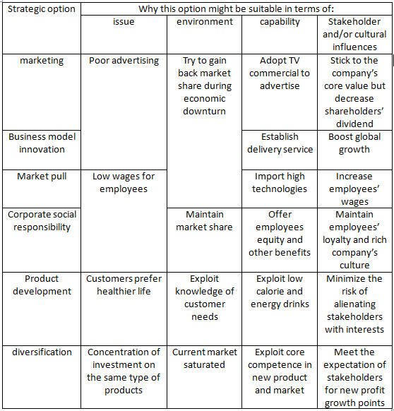

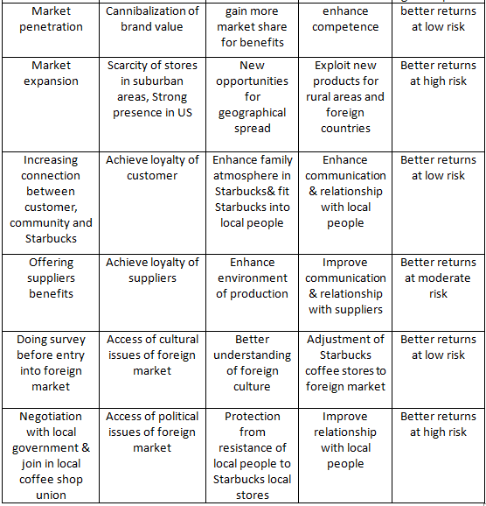

## Acceptability:

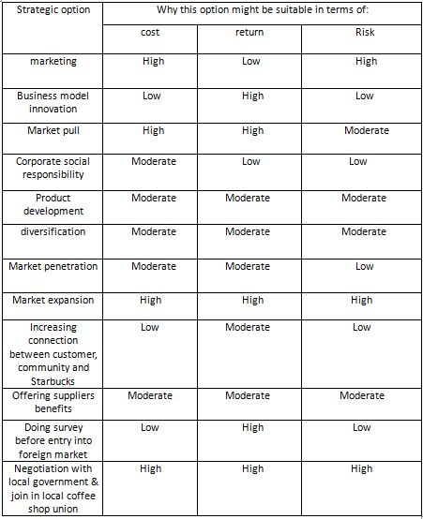

## Feasibility:

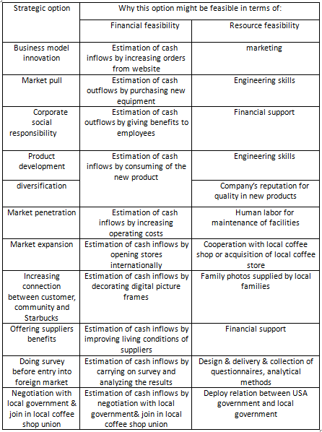

So finally we can assess the strategies by

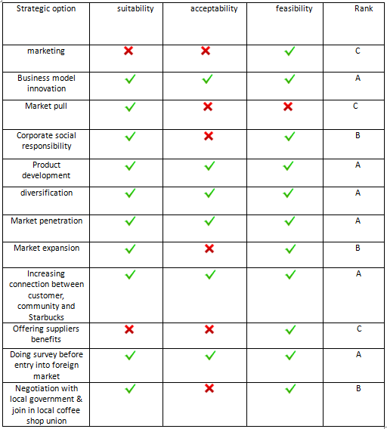

From what has been discussed above, we can conclude that Rank A strategies, such as Business innovation model, Product development, Diversification, Market penetration, Increasing connection between customer, Community and Starbucks, Doing survey before entry into foreign market, are recommended to be carried out by Starbucks.

# Future Recommendation:

Starbucks need to focus on keeping ground of some markets it has already entered but is now losing market share due to fierce competition. Initially the company needs to focus on saving itself from entering the worst situation where it is heading to. The first and foremost strategy to implement is cost reduction, this will help stabilize the company and whatever savings are made can be used elsewhere for e.g. product innovation or expanding into other undiscovered yet profitable markets. To implement the cost reduction strategy Starbucks need to shut down stores which are not generating enough revenue and instead are becoming most costly to afford in terms of their maintenance, i.e. bills and other services. In the previous year’s Starbucks had concentrated its stores in certain areas that it was leading to self-cannibalization of the brand and instead causing losses and hurting the brand image. The company needs to shut down those stores which are not generating any profits let alone the money to sustain the stores themselves.

There are still some undiscovered markets such as Brazil which seems to be huge and may have the potential to help generate revenue for the company. A good idea for stepping in the market is by becoming a sponsor of the Olympics which will be held in Brazil. This is an excellent way to attract people who are unaware of the brand simply by allowing tourists to come into Brazil and increasing it sales and causing more awareness of the Starbucks coffee. Local people are going to be attracted are they seeing foreign tourists buying the product.

Starbucks should accommodate with the general trends in all the markets. For the last few years till now there is a fitness craze around the world. People are looking to get healthy by eating healthy and therefore in this modern world of sedentary lifestyle people are always in search of healthy fast-food. Therefore Starbucks should try to create a healthy low calorie coffee line to attract more people in and hence generate more income. This strategy is based upon product innovation and product differentiation. Another bright idea is to push its already existing products into the international market such as the coffee machine. Coffee beans for those machines can then be sold wherever there is a large market for the coffee machines. For example in India people do not like the strong taste of original coffee usually sold in Starbucks. They like to make their own by adding greater quantity of milk according to their taste. Hence having these machines in such a large market where there is demand and then selling the coffee beans can help to keep the local customers attracted as they get freedom of choice to brew their own coffee at home according to their taste and needs.

As mentioned earlier people in some European countries such as Spain and Italy, prefer bakery items with their coffee. Hence it is best for Starbucks to fulfill their needs by not just providing coffee but along with it high quality bakery items such as biscuits, cakes, croissants and muffins. Having discounted coffee along with the bakery goods can attract people since they are looking to have proper breakfast or snacks with their coffee.

In markets with fierce competition where there are already excellent coffee makers such as in Italy and France people are willing to pay a very high price for proper luxurious coffee . They consider coffee as a luxury product and do not mind to always go and sit in neat restaurants and cafes with elegant cutlery just to have coffee.

On the other hand Starbucks provides relatively cheaper coffee with comparatively low quality and people consider it as junk coffee in disposable paper/plastic cups. Therefore instead of wasting its energy and resources on focusing on just the quality Starbucks should consider making a second brand which is low-priced and introduce it in markets where people do not enjoy coffee as a luxury product. This is because it is not beneficial for Starbucks to compete with the high end coffee makers as it will be wasting its time, energy and efforts. It is rather more helpful to use what it has got and take it towards the lower end market to bring in more customers who cannot currently afford coffee even at the prices at which Starbucks sell. This lower priced brand has the capability to excel in countries where the general population is poor and people do not really consider coffee as a necessity.

Implementing the above strategies can help Starbucks to step out of the financial crisis it has landed itself into. This could eventually lead it back to the top and remain successful for the years to come.

# References:

Books:

Gerry Johnson, Kevan Scholes and Richard Whittington (2005) Strategic choice. ***Exploring Corporate Strategy 7th Edition*.** London: the copyright licensing agency ltd. PP.233-383

Gerry Johnson, Kevan Scholes and Richard Whittington (2008) Strategic choice. ***Exploring Corporate Strategy 8th Edition*.** London: the copyright licensing agency ltd. PP.215-392

Robert M. Grant (2010) Competitive advantage. ***Contemporary Strategy Analysis* *7th* Edition.** UK: John Wiley & Sons Ltd. PP.207-328

Ross Gittell, Matt Magnusson, and Michael Merenda, **The Sustainable Business Case Book**, chapter 9.2

**Starbucks Annual Reports** [online],http://investor.starbucks.com/phoenix.zhtml?c=99518&p=irol-reportsAnnual

(2008, 06). **Swot Starbucks**. StudyMode.com. Retrieved 06, 2008, [online] http://www.studymode.com/essays/Swot-Starbucks-152355.html

James Heavey, **Starbucks a Strategic Report**, 2010, [online] http://zh.scribd.com/doc/27614539/Starbucks-a-Strategic-Report-by-James-Heavey

**How to Make Healthier Lifestyle Choices**, 2012, [online] http://idiva.com/photogallery-health/how-to-make-healthier-lifestyle-choices/17088/2

**Product Recall: Starbucks Coffee Mugs -- Handle Can Break**,2007, [online] http://voices.yahoo.com/product-recall-starbucks-coffee-mugs-handle-break-697696.html?cat=7

Stephan Faris (2012) **Gounds Zero: A Starbucks-Free Italy** [online]. Available from: <http://www.businessweek.com/magazine/grounds-zero-a-starbucksfree-italy-02092012.html> [Accessed 2 March 2013]

Point Consulting (2012) **Where is Starbucks in Italy** [online]. Available from: <http://point-consulting.blogspot.co.uk/2012/07/where-is-starbucks-in-italy.html> [Accessed 2 March 2013]

Burt Helm and Jenna Goudreau (2007) **Is Starbucks Pushing Prices Too High?** [online]. Available from: <http://www.businessweek.com/stories/2007-08-01/is-starbucks-pushing-prices-too-high-businessweek-business-news-stock-market-and-financial-advice> [Accessed 3 March 2013]

Sampson Lee (2007) **Are Starbucks’ Prices Too High?** [online]. Available from: <http://www.customerthink.com/article/are_starbucks_prices_too_high> [Accessed 3 March 2013]

Joshua Kennon (2012) **Starbuck Franchise Value** [online].

Available from: <http://beginnersinvest.about.com/cs/newinvestors/a/021103a.htm> [Accessed 4 March 2013]

# James A. Cooke (2012) From bean to cup: How Starbucks transformed its supply chain [online]. Available from:

# http://www.supplychainquarterly.com/topics/Procurement/scq201004starbucks/ [Accessed 4 March 2013]